InvestigateIQ
AI-Powered AML Investigation Copilot
CEO Playbook — Architecture, Implementation, UI & Demo

Capstone Project — Leadership with AI, IIT Mumbai
Date: 28 September 2026
Status: Draft — pending team confirmation on named decisions (see Section 10)

1. Executive Summary — Why We Will Win
This is a CEO-level read of the plan: what we are building, why it beats a generic submission, and what has to be true on presentation day for it to land. Every section after this one exists to make this true.

1.1 The core bet
We are not building a demo of an AI feature. We are building one believable, end-to-end investigation — alert to evidence to a human decision — with every AI claim traceable to a real record, and every recommendation traceable to a cited knowledge-base document. That is rarer than it sounds, and it is exactly what the rubric rewards: process understanding, AI appropriateness, architecture quality, guardrails, and communication.

1.2 What differentiates us
- A twin case (C1 suspicious / C2 legitimate) proves the AI investigates rather than accuses — most teams will only show the AI catching something.
- Evidence-status tagging (Verified / Inferred / Missing / Conflicting) with a grounding validator — most teams will show a chatbot that sounds confident; ours shows exactly what it does and does not know.
- A real retrieval layer (RAG over a curated, cited knowledge base in OKF format) behind every recommended next step — not a hardcoded prompt.
- A visible boundary between what the AI drafts and what the human decides, enforced in the UI, not just claimed in a slide.
- A live, conversational demo (ask a question, get a cited answer) — more memorable and more forgiving on stage than clicking through static screens.

1.3 The decision that makes this achievable in the time we have
We deliberately scoped down from a multi-screen enterprise product (login/roles, case queue, admin config, escalation dashboard) to a single Investigation Copilot workspace. Nothing rigorous was cut — only the surrounding product chrome. This is what makes "presenting half the blueprint" the right call, not a weakness: we build one thing completely instead of six things partially.

1.4 What winning looks like
By demo day: one Copilot workspace, two fully worked cases (C1 and C2), a live Q&A that answers correctly and cites its sources, one human decision recorded with rationale, and an audit log that proves it all happened in order. If we can show that in 5 minutes without anything breaking, we win on substance — the rest of the 15 minutes is framing.

2. Product Definition

2.1 One-line statement
An AI Copilot that turns an AML alert into an evidence-grounded conversation with the investigator, citing every claim and every recommendation, while the investigator keeps every decision.

2.2 Frozen scenario
Case | Story | What it proves
C1 — Suspicious | Apex Global Trading Ltd. (import/export, ₹8–12M expected monthly volume) receives ₹8M from a new, unrelated counterparty; 86% moves out within 48h across two accounts. | Verified + Missing evidence; no counter-evidence on file; AI recommends escalation-track next steps.
C2 — Legitimate twin | Same business, same size and speed of movement, but the credit is a documented, invoiced trade payment and the outbound transfer is to a verified, long-standing supplier. | Same trigger fires; Verified counter-evidence changes the recommended priority. The human still decides.

2.3 In scope vs. out of scope (unchanged from the agreed blueprint)
- In scope: alert-to-conclusion investigation for this one scenario family, natural-language Q&A, evidence-status tagging, grounded recommendations, human decision + audit trail.
- Out of scope: replacing the bank's real monitoring engine, autonomous case disposition, autonomous SAR/STR filing, production security/IAM certification.

3. End-to-End Workflow
Eight stages, from an existing bank alert to an audited human decision. Stages 1–5 are AI-assisted; stages 6–7 are where accountability sits.
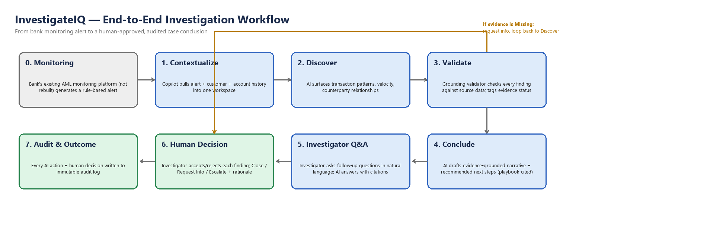
Stage | What happens | Who / what is accountable
0. Monitoring | Bank's existing AML monitoring platform generates a rule-based alert (not rebuilt by us). | Existing system
1. Contextualize | Copilot assembles alert + customer profile + account history into one workspace. | Context Agent
2. Discover | AI surfaces transaction patterns, velocity, and counterparty relationships. | Discovery Agent
3. Validate | Every finding is checked against source data and tagged with an evidence status. | Grounding Validator
4. Conclude | AI drafts an evidence-grounded narrative and playbook-cited next steps (via RAG). | Conclusion Agent
5. Investigator Q&A | Investigator asks follow-up questions in natural language; AI answers with citations. | Copilot chat
6. Human Decision | Investigator accepts/rejects each finding; closes, requests info, or escalates — with rationale. | Investigator (human)
7. Audit & Outcome | Every AI action and every human decision is written to an immutable audit log. | System (automatic)

If evidence is tagged Missing, the investigator can request more information, which loops back to Discover rather than forcing a premature decision — shown as the amber loop in the diagram above.

4. Architecture
Governing principle: compute deterministically, reason with the LLM, verify before display. No number the investigator sees was calculated by the language model.
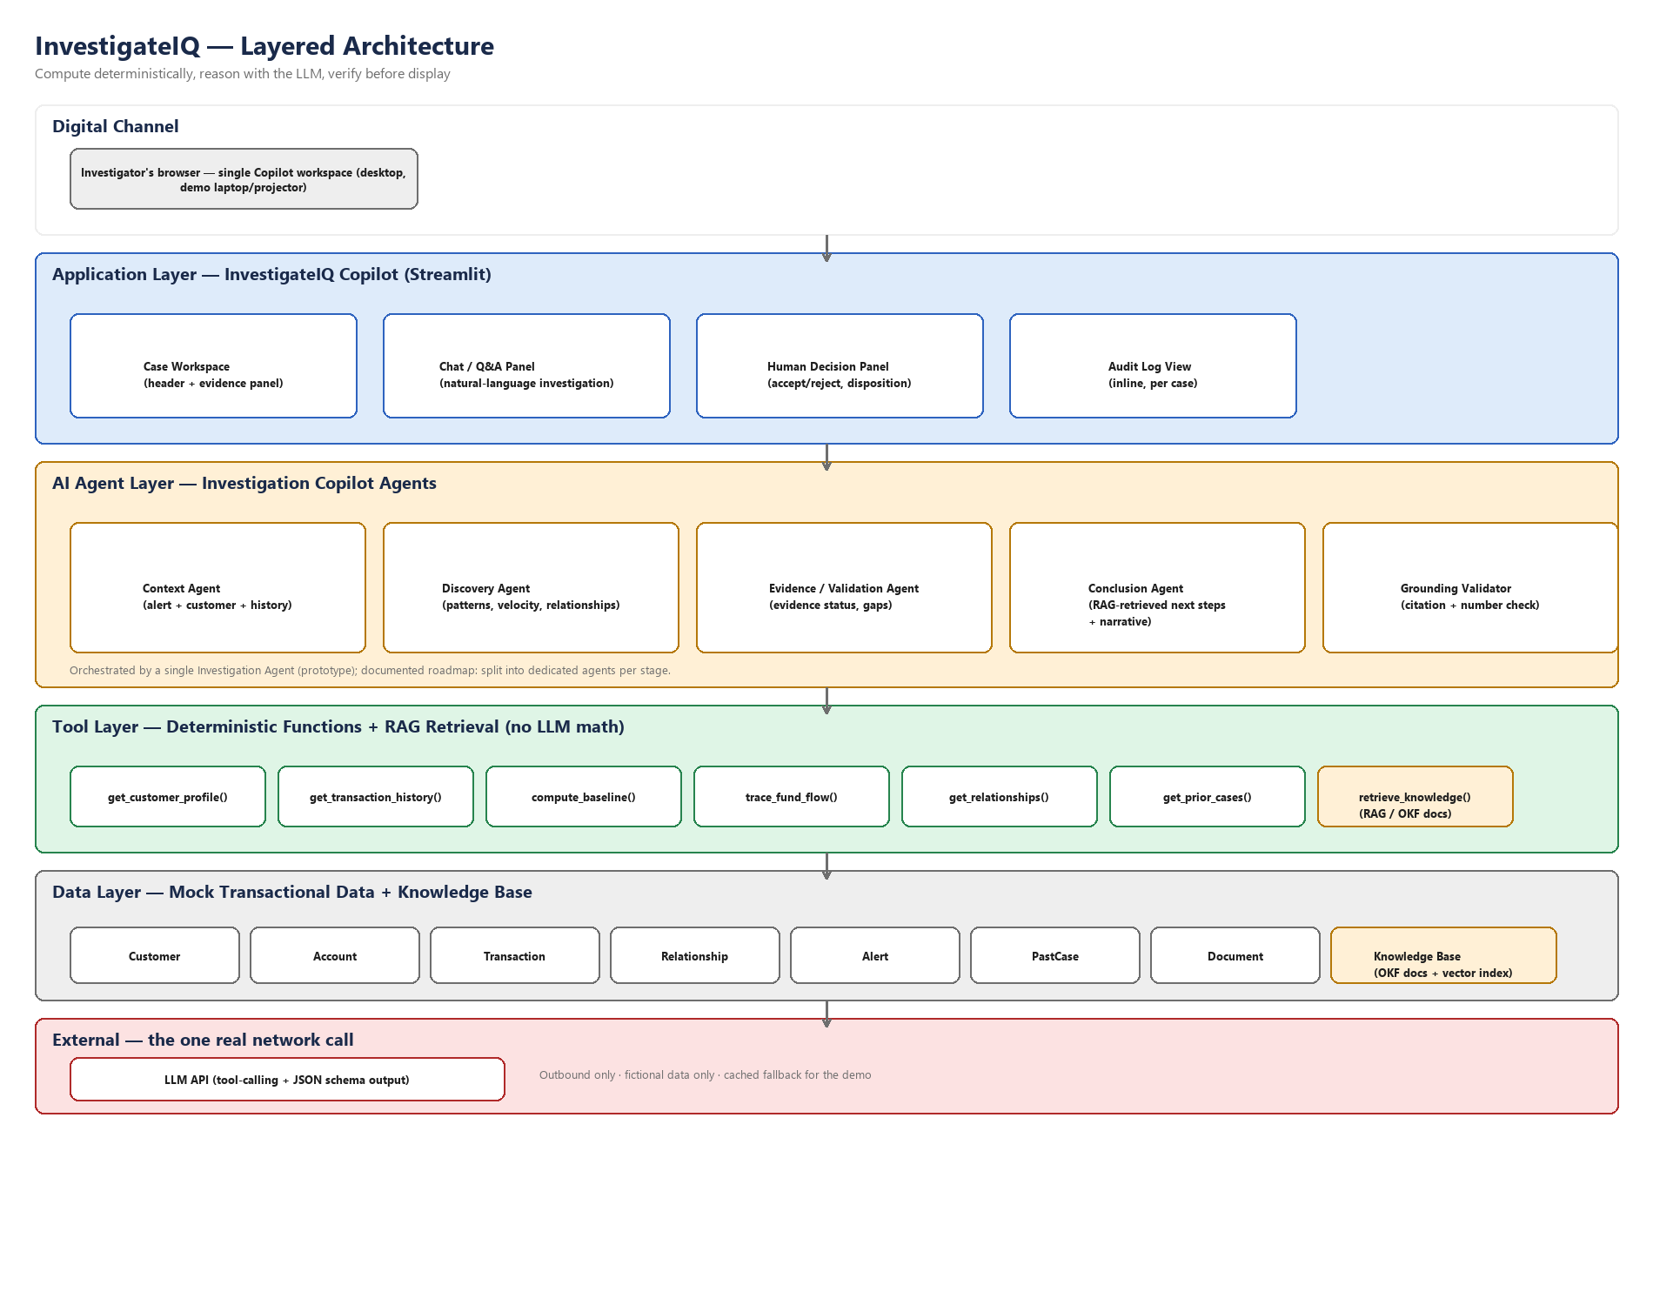
Layer | Responsibility | Built for prototype
Digital Channel | Investigator's browser, single Copilot workspace. | Desktop only, laptop/projector
Application | Case workspace, chat/Q&A panel, human decision panel, inline audit log. | Streamlit
AI Agent | Context, Discovery, Evidence/Validation, Conclusion agents + Grounding Validator. | One orchestrating agent (prototype); roadmap: split per agent
Tool | Deterministic functions (baseline, fund-flow trace, relationships) + RAG retrieval. | Python functions
Data | Mock transactional tables + the knowledge base (OKF documents + vector index). | CSV/SQLite + in-memory vector index
External | The one real network call: the LLM API (tool-calling, JSON-schema output). | Hosted LLM API, cached fallback for the demo

5. AI Agent Responsibilities — Who Does What
Answering directly: which agent is responsible for which task. In the prototype these run as staged tool-calling steps inside one orchestrating Investigation Agent; the table below is the logical division of labor, and is also the documented roadmap for splitting into five dedicated agents later.
Agent | Task | Input | Output | Guardrail
Context Agent | Assemble alert + customer + account history into one case object. | alert_id, customer_id, account_id | Structured case context | Read-only; no data written back
Discovery Agent | Compute baseline deviation, velocity, trace fund flow, surface relationships. | Case context | Pattern findings list | All numbers computed by code, not the LLM
Evidence / Validation Agent | Cross-reference findings against source data; classify evidence status. | Findings list | Tagged findings (Verified/Inferred/Missing/Conflicting) | "Verified" only when directly supported
Conclusion Agent | Retrieve relevant knowledge (RAG), draft narrative + playbook-cited next steps. | Tagged findings + retrieved knowledge | Draft case narrative + next steps | Next steps must cite a knowledge-base doc ID
Grounding Validator | Check every citation resolves to a real record or doc; reject/downgrade if not. | Draft report | Validated report (validator_result: PASS/FAIL) | The last line of defense against hallucination

6. Knowledge Base, RAG & OKF — How the Copilot's Knowledge Is Built
Direct answer to "are we using RAG, and how are we training the data": we are not training or fine-tuning a model. Our dataset is small and synthetic, which makes fine-tuning both infeasible and inappropriate — a fine-tuned model's outputs are not individually traceable to a source, which would undercut the entire "grounded, not hallucinated" positioning of this product. Instead we use Retrieval-Augmented Generation (RAG): the AI retrieves from a small, curated, human-authored knowledge base at query time, and every recommendation it gives must cite the specific document it came from.

6.1 What OKF is, and why we're using it
OKF (Open Knowledge Format) is an open, vendor-neutral specification published by Google Cloud in 2026 for storing knowledge as plain markdown files with YAML frontmatter — readable by humans, indexable by any tool, git-versionable, requiring no database or SDK. It is designed specifically for AI agents to retrieve curated, cited knowledge instead of re-deriving context from scattered sources each time.
We store our AML playbook and policy knowledge as OKF documents. This is a deliberate, current, and citable technical choice for the presentation: it is not a toy format we invented, and it directly reinforces our traceability story — every recommendation the AI makes can be traced to an actual file the team wrote and versioned, which the investigator can open and read.

6.2 Build time vs. query time
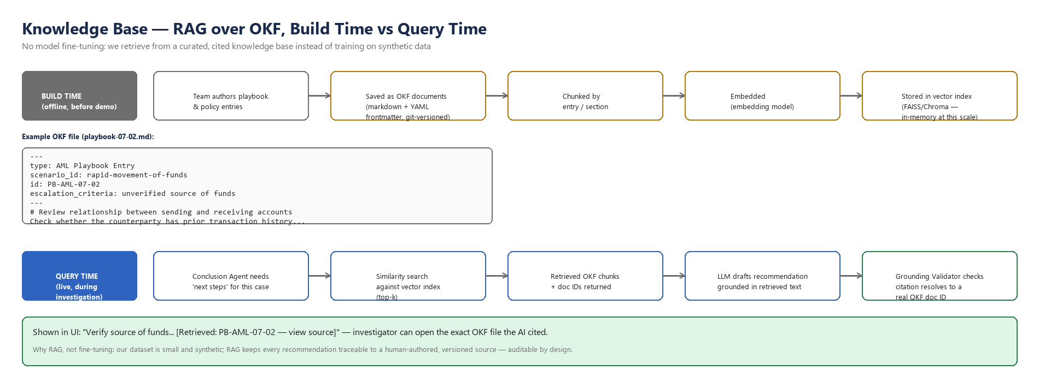

Build time (done once, before the demo)
- The team authors playbook and policy entries in plain language.
- Each entry is saved as an OKF document: a markdown file with a YAML frontmatter block (type, scenario_id, id, escalation_criteria) and a markdown body.
- Documents are chunked by entry/section.
- Each chunk is embedded using an embedding model.
- Embeddings are stored in a vector index — given our small corpus (roughly 10–15 documents), an in-memory index (FAISS or Chroma) is entirely sufficient; no dedicated vector database infrastructure is needed.

Query time (live, during the investigation)
- The Conclusion Agent needs a recommended next step for the current case's scenario.
- It runs a similarity search against the vector index and retrieves the top-k most relevant chunks.
- Each retrieved chunk comes back with its OKF document ID (e.g., PB-AML-07-02).
- The LLM drafts its recommendation using only the retrieved text as grounding — not its own training-data memory of AML procedure.
- The Grounding Validator checks that the cited document ID actually exists and actually contains the claim before it is shown to the investigator.

6.3 How this shows up in the demo
When the investigator asks "what should I do next?", the Copilot answers with a citation like "[Retrieved: PB-AML-07-02 — view source]". Clicking it opens the actual OKF markdown file. This is the single most convincing 30 seconds of the technical demo: it proves the recommendation isn't invented.

6.4 Scope for the timeline we have
Item | Build for demo | Document only (roadmap)
Knowledge base size | 10–15 OKF documents covering the frozen scenario | Full policy library, multi-scenario coverage
Retrieval | In-memory vector index, top-k similarity search | Managed vector DB, hybrid search, re-ranking
Knowledge sources | Team-authored playbook + policy entries | Real bank policy documents, legal review
Data schema as OKF | Optional: document our own data tables as OKF too (bonus, cheap, doubles as documentation) | —

7. UI / UX — What the Product Will Look Like
One workspace, three panels, one visible boundary between AI and human. This is the entire build surface for the UI.
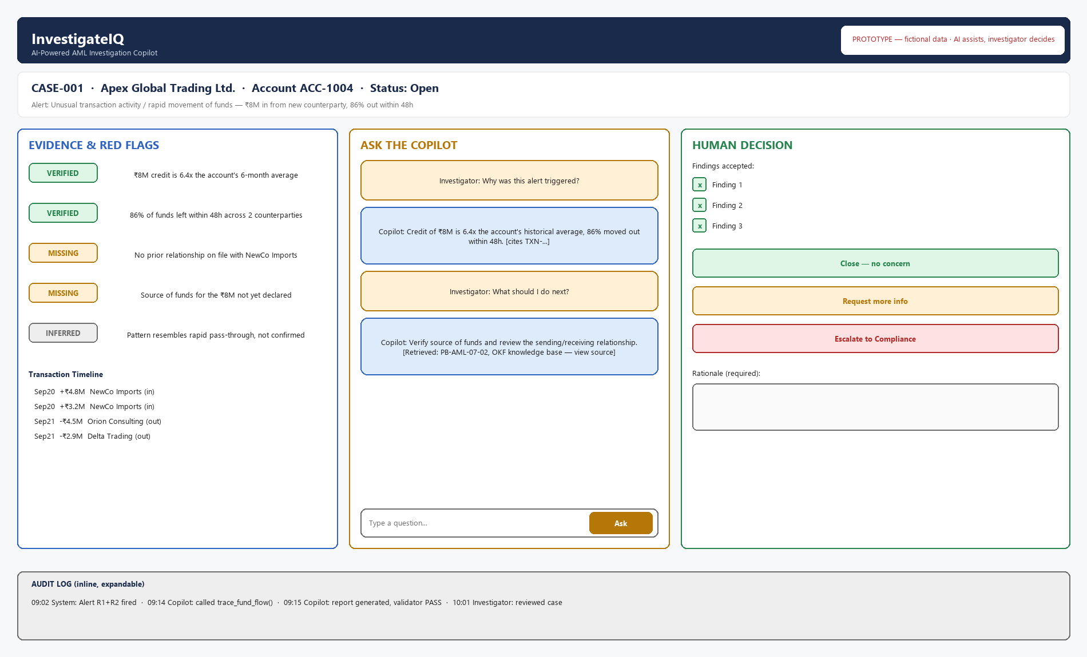

7.1 The three panels
- Evidence & Red Flags (left, blue) — every AI finding with a color + text evidence-status tag, plus the transaction timeline. This panel never contains an editable field — it is the AI's draft, read-only.
- Ask the Copilot (center, amber) — natural-language chat. Every AI answer that makes a claim carries an inline citation, either a transaction ID or a knowledge-base document ID.
- Human Decision (right, green) — the investigator accepts or rejects each finding individually, then chooses Close / Request more info / Escalate. A rationale is mandatory before any of those three buttons submits.
- Audit log (bottom strip, inline) — every AI tool call and every human action, timestamped, always visible without navigating away.

7.2 Responsibility of the UI/UX role
- Own this wireframe and the visual language: color-coded panel borders so the AI/human boundary is legible at a glance, even from the back of a room.
- Enforce that evidence-status tags always carry both color and text (never color alone) — accessibility, and legible on a projector.
- Build the actual Streamlit implementation of the three-panel layout from this wireframe.
- Own the persistent "Prototype — fictional data, AI assists / investigator decides" banner — it must be visible on every screen, not just the first one.
- Run a projector/low-light readability pass before the final rehearsal — font sizes and contrast, not just correctness.

8. Team & Role Responsibilities
Two different "who does what" questions, answered separately: the human roles that build and present this (below), and the AI agents that run inside it (Section 5). This section answers what the CEO, Solution Architect, and Business Analyst are each doing.
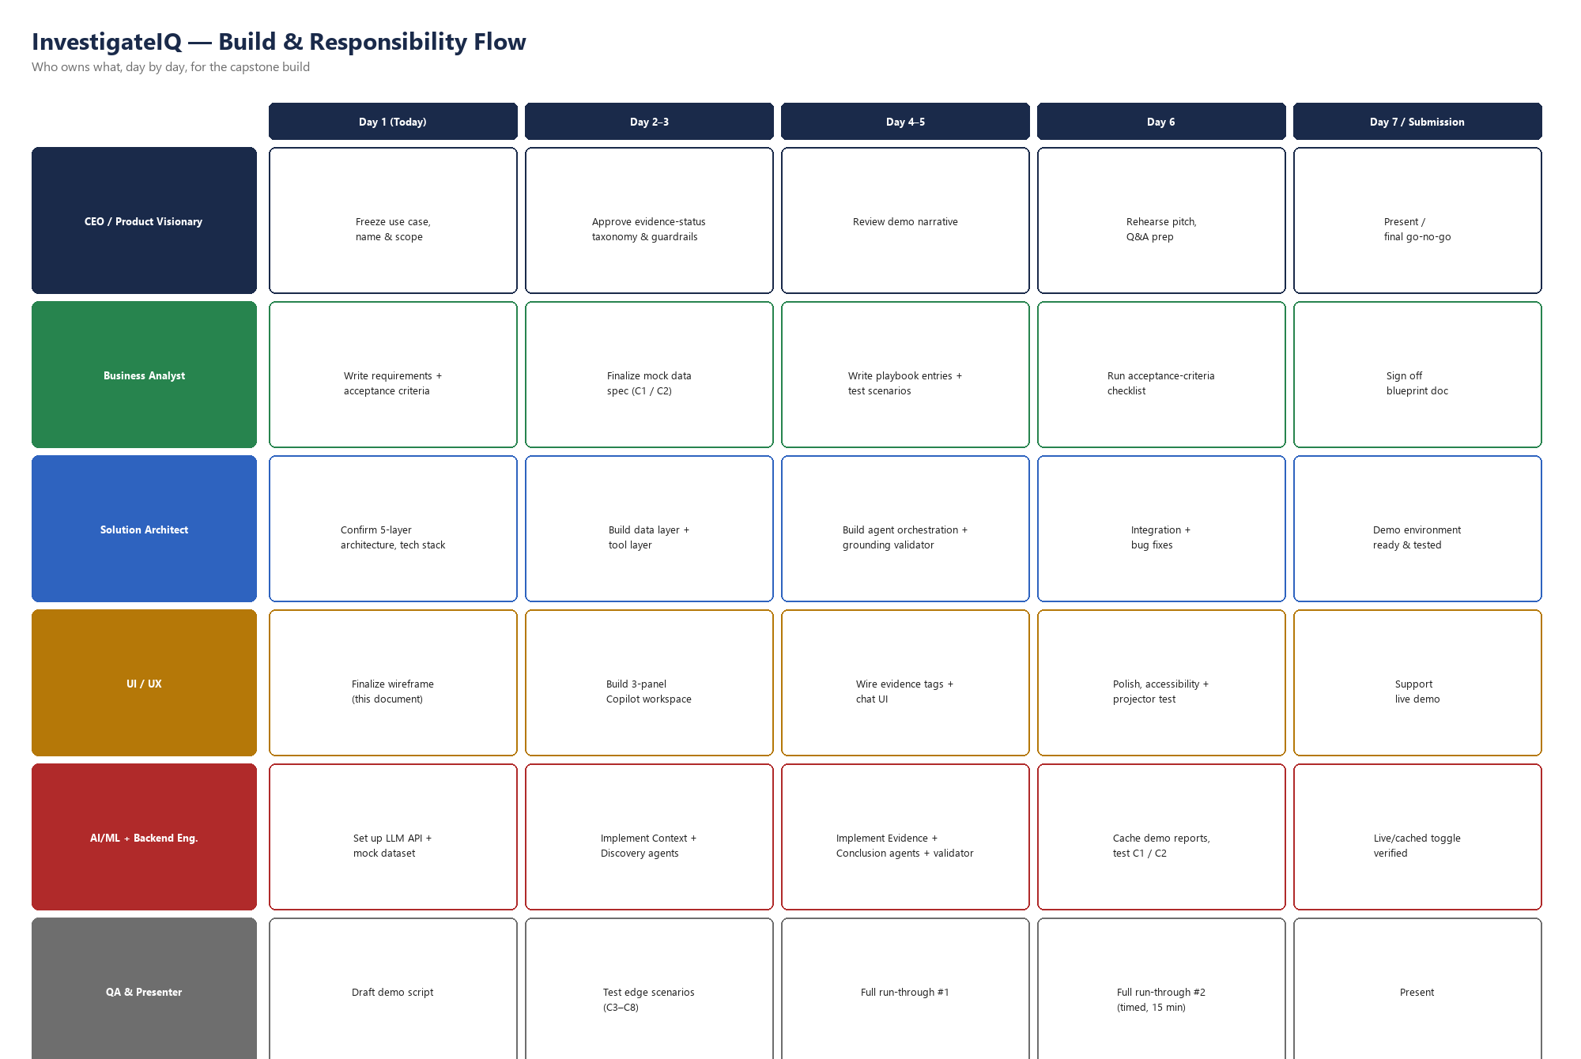

8.1 Role definitions

CEO / Product Visionary
Owns the single question everything else answers to: does this decision help us win. Freezes the use case, the name, and the scope so nobody re-litigates it mid-build. Approves the evidence-status taxonomy and guardrail language before it's built. Owns the demo narrative and, most likely, delivers the presentation (only one person presents). Suggested owner: Sweta Singh, based on the direction she has driven throughout this planning — confirm with the team.

Solution Architect
Owns the five-layer architecture in Section 4 and the technology choices behind it (Streamlit, the tool layer, the vector index choice). Builds or directly oversees the data layer, tool layer, agent orchestration, and the Grounding Validator. Owns the technical risk register and the go/no-go call on whether the live demo or the cached fallback runs on the day.

Business Analyst
Owns the requirements and acceptance criteria (Section 9), the exact wording of the C1/C2 mock data spec, and the playbook/policy entries that become the OKF knowledge base content (Section 6). Runs the acceptance-criteria checklist before anything is declared "done," and owns the final sign-off that the built prototype matches what this document says it does.

UI / UX
Detailed in Section 7.2. In short: owns the wireframe, builds the three-panel workspace, and is responsible for the product being legible to someone seeing it for the first time in a 15-minute slot.

AI/ML + Backend Engineer(s)
Implements the agents in Section 5, the RAG/OKF pipeline in Section 6, and the LLM API integration in Section 4. Owns the cached-report fallback so a live API failure never derails the demo.

QA & Presenter
Owns the demo script (Section 11) and runs it against every test scenario, not just the happy path. Runs both full timed rehearsals before submission. May be the same person as the CEO/presenter, or a separate role — the team's call.
Note: name-to-role assignment above is a starting proposal, not a fact about anyone's skills — confirm final ownership against the Team & Strengths sheet in the team-plan workbook.

9. Requirements Coverage — What We Will and Won't Cover
Said plainly, for the CEO-level decision this represents: we are covering the full depth of one scenario, not partial depth across many. This table is what "we're presenting half of it" should mean in practice.
Capability | Status | Notes
Alert-to-conclusion workflow (Section 3) | Build | Both C1 and C2 run end to end
Evidence-status tagging + Grounding Validator | Build | Core differentiator — must work reliably
Natural-language Q&A (chat) | Build | Minimum: 4–5 rehearsed question types work correctly, live or cached
RAG over OKF knowledge base | Build | 10–15 documents; must be demoable with a real citation click-through
Human decision panel + audit log | Build | Mandatory rationale enforced
Login / role-based access | Document only | Roadmap section; mock auth at most, not a build target
Case queue dashboard (multi-case list) | Document only | Demo runs from two pre-selected cases directly
Escalation / Compliance queue screen | Document only | Escalation action is logged; no separate screen
Admin rule-configuration screen | Document only | Rule thresholds fixed in code for the demo
Second trigger scenario / typology | Document only | Only if all of the above is done early
Multi-agent split (5 separate agents) | Document only | Prototype uses one orchestrating agent; documented as the next phase

10. Detailed Implementation Plan
Expanded, day-level view of the swimlane in Section 8. Today is 28 September 2026; submission window is the first/second week of October — confirm the exact date.
Day | Milestone | Owner
Day 1 (28 Sep) | Use case, name, and scope frozen. Architecture confirmed. Requirements + acceptance criteria drafted. | CEO, Solution Architect, Business Analyst
Day 2–3 | Mock data (C1/C2) finalized. Data + tool layer built. OKF knowledge-base documents authored. 3-panel workspace scaffolded. | Business Analyst, Solution Architect, UI/UX
Day 4–5 | Context + Discovery agents built. Evidence + Conclusion agents + Grounding Validator built. RAG retrieval wired in. Evidence tags + chat UI wired. | AI/ML Engineer, Solution Architect, UI/UX
Day 6 | Integration + bug fixes. Demo reports cached. Accessibility/projector pass. First full timed run-through. | Whole team
Day 7 / Submission | Second full timed run-through (15 min). Live/cached toggle verified. Final blueprint sign-off. Present. | Whole team, Presenter

10.1 Open decisions before build starts
- Who owns the LLM API key and budget (even if near-zero)?
- Which embedding model / vector index library — confirm library availability for the team's environment.
- Who is the single presenter, and who is the backup?
- Exact submission date and format from IIT Mumbai.

11. Demo Script — 15 Minutes
One presenter. The script is built so the strongest technical proof points (twin case, live citation) land in the first 8 minutes, before any Q&A risk.
Time | Beat | What to show / say
0:00–1:30 | The problem | Investigators piece together evidence from 6–8 systems by hand. State the cost of that in one sentence, then move.
1:30–3:00 | The architecture, fast | Show the layered architecture diagram (Section 4). One sentence per layer. Do not linger.
3:00–8:00 | Live case walkthrough — C1 | Open CASE-001 (Apex Global Trading). Show the alert trigger, the evidence panel with status tags. Ask the Copilot live: "Why was this alert triggered?" then "What should I do next?" — let the citation (PB-AML-07-02) appear and click through to the actual OKF file.
8:00–10:30 | The twin case — C2 | Switch to the legitimate case on the same trigger. Show the same evidence-status mechanism now surfacing counter-evidence. This is the single strongest contrast in the whole demo — say explicitly: "same alert pattern, different evidence, the AI didn't decide either way."
10:30–12:00 | Human decision + audit | Accept/reject findings on screen, submit a decision with rationale, then open the audit log and show the full trace from alert to decision.
12:00–13:30 | What we deliberately did not build, and why | One slide: the requirements-coverage table (Section 9). Frame it as a decision, not a shortfall.
13:30–15:00 | Close + Q&A buffer | One sentence on the roadmap (multi-agent split, real integrations). Stop talking with time left for questions — do not run over.

11.1 Rehearsal rule
Rehearse once with the network disconnected, forcing the cached-report fallback. If the live demo breaks on the day, the presenter should be able to say "switching to cached mode" without missing a beat, not discover the fallback exists mid-sentence.

12. Risks & Win Safeguards
Risk | Safeguard
Live LLM call fails mid-demo | Cached report + cached chat answers for both C1 and C2; rehearsed offline switch
RAG retrieval returns a weak/irrelevant citation live | Pre-test the exact 4–5 questions used in the demo script against the real index before rehearsal
Twin-case contrast doesn't land verbally | Say the contrast sentence verbatim, don't improvise it — see Section 11 script
Evaluator asks "why not fine-tune a model?" | Answer is pre-written in Section 6: dataset too small, RAG keeps everything traceable — say this, don't improvise
Running over 15 minutes | Section 11 has hard time boxes; QA owns timing the second rehearsal and flags the presenter if a beat runs long

13. Closing — The CEO's Call
Every generic AI-capstone submission claims "human in the loop" and "explainable AI" on a slide. Very few prove it live, on two cases that look identical until the evidence says otherwise, with a citation the evaluator can click and read themselves. That is the entire strategy: fewer features, proven completely, demonstrated live, framed as a deliberate decision rather than a shortfall.
The team's job from here is not to add more scope. It's to protect the four things that make this win: the twin case, the evidence-status/grounding rigor, the live RAG citation, and a rehearsed, timed script. Everything else in this document is in service of those four things.

